
Joseph Banks
Secondary College

Research Methods and Biological Influences
Worth 5% of the school mark
Question/Answer Booklet

PSYCHOLOGY
Units 1 and 2
Student name : _________________________________________

Time allowed for this paper

Reading time before commencing work: thee minutes
Working time for the paper: sixty-one minutes

Materials required/recommended for this paper
To be provided by the supervisor:
This Question/Answer Booklet
Formulae and Data Booklet

To be provided by the candidate:
Standard items: pens (blue/black preferred), pencils (including coloured), sharpener,
correction tape/fluid, eraser, ruler, highlighters.

Special items: non-programmable calculators approved for use in the WACE examinations

Important note to candidates
No other items may be taken into the examination room. It is your responsibility to ensure that you do not have any unauthorised notes or other items of a non-personal nature in the examination room. If you have any unauthorised material with you, hand it to the supervisor before reading any further.
Structure of this paper

Section | Number of questions available | Suggested working time  (minutes) | Your Mark | Marks available | Percentage of test
Section One:  Research Methods | 2 | 20 |  | 33 | 50
Section Two:  Short Answer | 3 | 41 |  | 27 | 50
 |  | Total |  | 60 | 100

Instructions to candidates

- The rules for the conduct of Western Australian external examinations are detailed in the Year 11 Information Handbook 2016. Sitting this examination implies that you agree to abide by these rules.

- Write your answers in this Question/Answer Booklet.

- When calculating numerical answers, show your working or reasoning clearly. Your working should be in sufficient detail to allow your answers to be checked readily and for marks to be awarded for reasoning.

In calculations, give final answers to one significant figures and include appropriate units where applicable.

- You must be careful to confine your responses to the specific questions asked and to follow any instructions that are specific to a particular question.

- Supplementary pages for the use of planning/continuing your answer to a question may have been provided at the end of this Question/Answer booklet. If you use these pages to continue an answer, indicate at the original answer where the answer is continued, i.e. give the page number.

Question One (12 marks)
Read the following scenario and answer the questions that follow
Renowned Perth Psychologist, Dr Wrona, was interested in the relationship between sleep levels and an individual’s mood state. After putting an advertisement in a local newspaper, she gathered 50 volunteers (ages 18-65), who experienced the following hours of sleep per night:
1-4 OR 6-9. She then asked them a series of open-ended questions in her clinic in order to understand the nature of their respective mood states.

a) Identify the Independent Variable/s. (1 mark)
________________________________________________________________________________________________________________________________________________________________

b) State the Dependent Variable. (1 mark)
________________________________________________________________________________________________________________________________________________________________

c) Create an operationalised hypothesis for this research study. (4 marks)
________________________________________________________________________________________________________________________________________________________________
________________________________________________________________________________________________________________________________________________________________

d) Identify the type of data collected by the psychologist. (1 mark)
________________________________________________________________________________________________________________________________________________________________

e) What are the three defining features of the scientific method. (1 mark)
________________________________________________________________________________

f) Name two examples of subjective quantitively data (2 marks)
________________________________________________________________________________

g) Name two examples of objective quantitively data (2 marks)

h)

Question Two (6 marks)
A research study was conducted to examine the effects of alcohol consumption and developing feelings of sadness. Fifty participants were randomly assigned to Group A or Group B.

Individuals performed the following sequence of tasks
Completed a mood rating scale
Discussed with the researcher three recent times when he/she felt sad:
Completed the mood rating scale again
Drank a moderate dose of ‘alcohol’ over a 20-minute period
Waited 20 minutes for the alcohol to be absorbed
Completed the mood rating scale again.

All participants were told that they would be given a moderate dose of alcohol to drink but only participants assigned to Group A were actually given alcohol. Group B were given a non-alcoholic beverage that appeared to be alcohol.
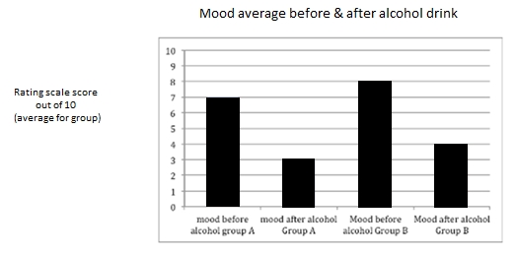

- With reference to the numeric data above summarise one key finding from the data (2 marks)
________________________________________________________________________________________________________________________________________________________________
________________________________________________________________________________________________________________________________________________________________

b) Identify two participant rights relevant to this study. Explain how the researchers would deal with this consideration in their research. (4 marks)
________________________________________________________________________________________________________________________________________________________________________________________________________________________________________________________________________________________________________________________________________________________________________________________________________________________________________________________________________

Question Three (7 marks)
Dr Stevens conducted a study with a group of Psychology students to determine the relationship between the numbers of hours spent studying Psychology per week and the final examination score. The results of this study are shown in the table below.
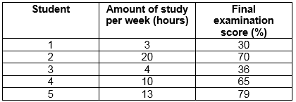

a) State the median examination score from this group. (1 mark)
___________________________________________________________________________

b) Calculate the mean number of hours studied by this group. (1 mark)
___________________________________________________________________________
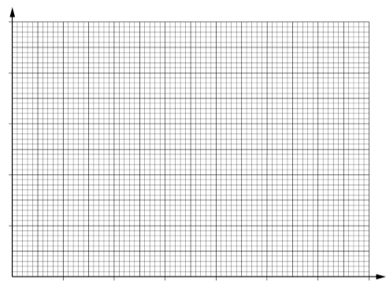
c) Plot an appropriate graph of these scores on the axes provided. Label the graph appropriately. (5 marks)
Question Four (8 marks)
Researchers are designing an experiment to determine whether listening to music while exercising causes people to exercise harder. There will be 100 participants in the experiment, 50 in the experimental group, and 50 in the control group.
a) List three extraneous variables that should be controlled in this experiment. (3 marks)
One: ________________________________________________________________________
Two: ________________________________________________________________________
Three: _______________________________________________________________________

b) Define the term operationalise (1 marks)
___________________________________________________________________________
___________________________________________________________________________

c) Define the independent variable. (1 marks)
___________________________________________________________________________
___________________________________________________________________________

c) Define the dependant variable. (1 marks)
___________________________________________________________________________
___________________________________________________________________________

e) In experimental research which group receives the independent variable? (1 mark)
___________________________________________________________________________

f) What is the purpose of a control group in experimental research? (1 mark)
___________________________________________________________________________

Section 2- Short Answer Questions- 5 Questions (37 marks)

Question Five (5 marks)

- Identify the parts of the neuron below (4 marks)

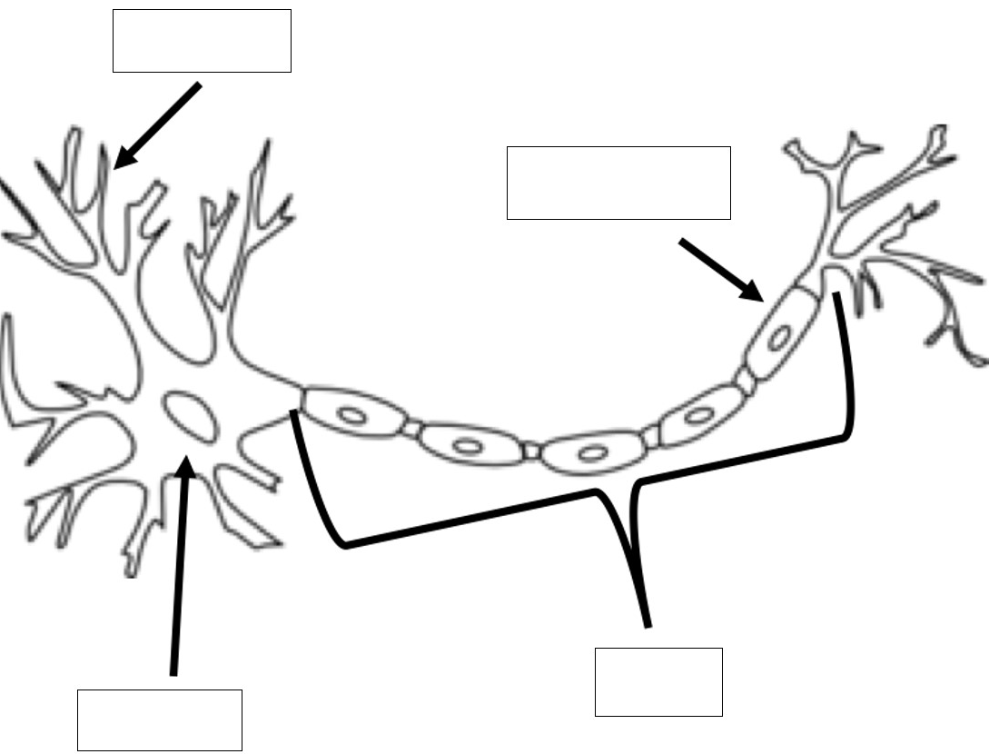

b) Outline the direction of neural transmission (1 mark)

________________________________________________________________________________
________________________________________________________________________________
Question Six (12 marks)

- Outline the key functions of the midbrain. (2 marks)
________________________________________________________________________________________________________________________________________________________________
________________________________________________________________________________________________________________________________________________________________

- Circle which area of the brain is the cerebellum located in: (1 mark)
Forebrain Hindbrain Midbrain

- Outline the key functions of the hindbrain. (2 marks)
________________________________________________________________________________
________________________________________________________________________________
________________________________________________________________________________________________________________________________________________________________

- Name the brain lobes and describe the functions of each in the table below. (6 marks)

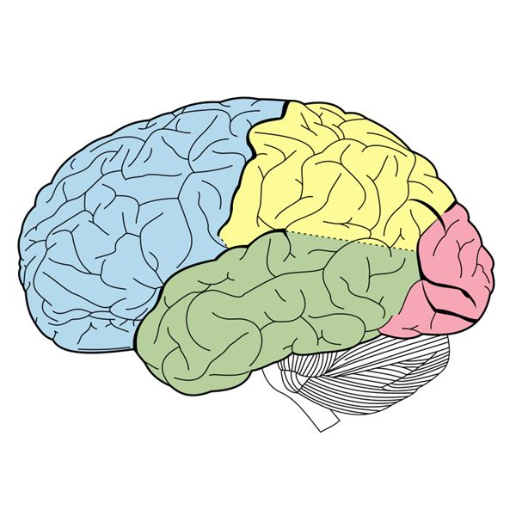
Lobe B

Lobe A

Lobe D
Lobe C

Lobe | Lobe Name | Lobe Function/s
A

B

C

Allen got up during the night to get a glass of water. While walking to the kitchen, he heard a sudden, loud noise. He was so scared that he tripped and fell, hitting his head on the wall. Since then, he has had difficulties with his vision, though there’s been no change in his ability to understand what people are saying or respond to them.
e) Which of his lobes seems most likely to have been injured? (1 mark)

__________________________________________________________________________________________________________________________________________________
f) Which of his lobes was most involved in processing the sound in the first place? (1 mark)
__________________________________________________________________________________________________________________________________________________

Question Seven (6 marks)
- Identify one example of a stimulant and describe one psychological and one physiological effect that the drugs can induce: (3 marks)
____________________________________________________________________________________________________________________________________________________________________________________________________________________________________________________________________________________________________
- Identify one example of a hallucinogen and describe one psychological and one physiological effect that the drugs can induce: (3 marks)
____________________________________________________________________________________________________________________________________________________________________________________________________________________________________________________________________________________________________
Question Eight (4 marks)

In class you will have examined the case study of Phineas Gage, that investigated how injuries to the brain can impact on a person’s thoughts, emotions and behaviour.

Explain with reference to this case study, how it has increased your understanding of the role and functions of parts of the brain. Ensure you:
- briefly outline why the person became of interest to psychologists
- identify what parts of the brain were involved
- explain what changes to their thoughts, emotions and/or behaviour occurred, or were possibly going to occur, as a result of their experience

________________________________________________________________________________________________________________________________________________________________________________________________________________________________________________________________________________________________________________________________________________________________________________________________________________________________________________________________________________________________
________________________________________________________________________________________________________________________________________________________________________________________________________________________________________________________________________________________________________________________________________________________________________________________________________________________________________________________________________________________________

